ADDRESS BOOKING SYSTEM

Cornerstone project work submitted to Aditya University in partial fulfilment of the requirements for the award of the Degree of

B.Tech. degree
in
Computer Science & Engineering (2026-2027)

M.UMA SANKAR | 26B21DS011
K.N.S.J.KUMAR | 26B21DS020
K.SATHVIK RAJA | 26B21DS009
R.SHANKAR | 25B11DS494
SUBMITTED BY

UNDER THE GUIDANCE OF
Guide Name
Designation
Department of CSE



SCHOOL OF ENGINEERING
Department of Artificial Intelligence and Machine Learning

CERTIFICATE

This is to certify that the Cornerstone project work entitled “BANKING PORTAL” is submitted by
M.UMA SANKAR (26B21DS011)
K.N.S.J.KUMAR (26B21DS020)
K.SATHVIK RAJA (26B21DS009)
R.SHANKAR (25B21DS494)

in partial fulfillment of the requirements for the award of the B.Tech. degree in Artifcial Intelligence and Machine Learning for the academic year 2025-2026.

Project Guide Head of the Department
Dr. M. Venkatesh, M. Tech, Ph. D. Dr. M. Venkatesh, M. Tech, Ph. D.
Associate Professor, Associate Professor,
Department of AIML Department of AIML


Department of Computer Science & Engineering
Aditya University, Aditya Nagar, ADB Road,
Surampalem, Kakinada, District, Andhra Pradesh, India - 533437

DECLARATION

I hereby declare that the Cornerstone project work entitled “TITLE OF THE PROJECT” is being submitted by me for the award of the B. Tech Degree in Computer Science and Engineering, Aditya University, Aditya Nagar, ADB Road, Surampalem is a record of original work carried out by us. We further declare that this project work has not been submitted, either in full or in part, for the award of any degree or diploma in this or any other institution. We also confirm that this work has been carried out with academic honesty and complies with the Institutional Academic Integrity and AI Usage Policy.

Submitted By
M.UMA SANKAR | 26B21DS011
K.N.S.J.KUMAR | 26B21DS020
K.SATHVIK RAJA | 26B21DS009
R.SHANKAR | 25B11DS494

Place:
Date:

DEPARTMENT OF COMPUTER SCIENCE & ENGINEERING
ADITYA UNIVERSITY, ADITYA NAGAR,
SURAMPALEM.

This is to certify that the cornerstone project entitled “PROJECT TITLE” is being submitted by NAME OF THE STUDENTS in partial fulfilment for the award of B. Tech Degree from Aditya University, is a record of original work done by them under my supervision. The contents of this project, in full or in parts, have not been submitted to any other Institute or University for the award of any degree or diploma.

Project Guide
Dr. Shaik Vahida
Assistant Professor
Department of CSE
Aditya University

ACKNOWLEDGEMENT
It is with immense pleasure that we express our sincere gratitude to our Cornerstone Project Guide, GUIDE NAME, DESIGNATION, who has guided us throughout the project. Her valuable support, encouragement, and guidance have greatly contributed to the successful completion of this work.

We would like to thank our Deputy Heads of the Department, DY HOD-1, DESIGNATION, DY HOD-2, DESIGNATION AND DY HOD-3, DESIGNATION, Department of CSE, for their support and valuable suggestions.

Our deepest thanks to our Head of the Department, HOD NAME, DESIGNATION & HOD, for her inspiration and for providing all the necessary facilities and resources required for this project.

We also extend our sincere thanks to DR. M.V. RAJESH, ASSOCIATE DEAN, SCHOOL OF COMPUTING, for his encouragement and support during our project.

We would like to express our sincere gratitude to DR. G. SURESH, REGISTRAR; DR. A. RAMESH, PRO VICE-CHANCELLOR (ENGINEERING & SCIENCES); DR. S. RAMA SREE, PRO VICE-CHANCELLOR (ACADEMICS); DR. M.B. SRINIVAS, VICE-CHANCELLOR; AND DR. M. SREENIVASA REDDY, DEPUTY PRO CHANCELLOR AND MANAGEMENT, ADITYA UNIVERSITY, for providing excellent infrastructure and state-of-the-art laboratories.

Finally, we would like to thank the FACULTY MEMBERS, LAB TECHNICIANS, NON-TEACHING STAFF, AND OUR FRIENDS who have directly or indirectly supported us in completing this Cornerstone project successfully.

Name of the Students
Date:
ABSTRACT
The Address Book System is a C++-based application developed to provide an efficient and systematic solution for managing contact information. Traditional address books rely on manual record keeping, which makes storing, searching, updating, and deleting contact information time-consuming and prone to errors. The proposed system overcomes these limitations by providing a simple, menu-driven platform for computerized contact management.
The system is implemented using Object-Oriented Programming (OOP) concepts in C++, including classes, objects, encapsulation, constructors, member functions, structures, arrays, and string handling. It allows users to add, display, search, update, delete, and sort contact records containing details such as Contact ID, name, mobile number, email address, residential address, and city. To improve reliability and usability, the system incorporates automatic Contact ID generation, mobile-number validation, duplicate phone-number detection, alphabetical sorting, and contact statistics.
The proposed system reduces the time and effort required to maintain contact records and provides organized access to information compared with traditional methods. Furthermore, the project demonstrates the practical application of fundamental OOP concepts and basic data-management techniques in solving a real-world problem. The system is designed to be simple, efficient, user-friendly, and suitable for small-scale contact management.

ABBREVATIONS
For your C++ Address Book System project, you can include the following abbreviations in your report:
Abbreviation | Full Form
OOP | Object-Oriented Programming
C++ | C Plus Plus
ID | Identification
UI | User Interface
CLI | Command-Line Interface
DB | Database
CRUD | Create, Read, Update, Delete
STL | Standard Template Library
I/O | Input/Output
ASCII | American Standard Code for Information Interchange
IEEE | Institute of Electrical and Electronics Engineers
UML | Unified Modeling Language
API | Application Programming Interface
No. | Number
e.g. | For Example

LIST OF FIGURES
For your Address Book System – C++ OOP Project, an IEEE-style report can have a List of Figures with figure numbers, titles, and page numbers.
Figure No. | Figure Title | Page No.
Fig. 1.4 | System Architecture of Address Book System | 5
Fig. 1.6  2.3.1 | Overall System Flowchart  Welcome screen | 6
Fig. 2.3.2 | Main Menu Interface | 10
Fig. 2.3.3 | Add Contact Module | 11
Fig. 2.3.4 | Display Contact Module | 12
Fig. 2.3.5 | Search Contact Module | 13
Fig. 2.3.6 | Update Contact Module | 14
Fig. 2.3.7 | Delete Contact Module | 15
Fig. 2.3.8 | Sort Contacts Module | 16
TABLE OF CONTENTS

CONTENTS | PAGE NO
Title Page | I
Certificate | II
Declaration | III
Acknowledgement | IV
Abstract | V
Abbreviations | VI
List of Figures | VII
CHAPTER -1 Project Planning
1.1. Problem statement
1.2. Project Objective
1.3. Planned Modules
1.4. System Architecture (Algorithm & Flowchart)
CHAPTER -1 Project Implementation
2.1. OOP Concepts Used for implementation
2.2. Code
2.3. Output Screens
CHAPTER-3 Conclusion & Future Scope
3.1. Conclusion
3.2. Future Scope

CHAPTER–1

PROJECT PLANNING

Problem Statement
Traditional address books generally use paper-based notebooks or unorganized digital records for storing contact information. As the number of contacts increases, maintaining and retrieving records becomes increasingly difficult. Searching for a particular contact manually requires additional time, while updating or deleting outdated information may result in errors or inconsistent records.
Traditional methods also provide limited facilities for sorting, validation, duplicate detection, and systematic organization. Incorrect phone numbers, duplicate records, and incomplete contact information may reduce the reliability of the stored data.
Therefore, there is a need for a simple computerized system that can efficiently store, retrieve, update, delete, and organize contact information.
The proposed Address Book System addresses these issues through a menu-driven C++ application based on Object-Oriented Programming principles. The system provides operations for contact creation, searching, modification, deletion, sorting, validation, and statistical information.

Project Objective
The primary objective of the project is to design and implement an object-oriented Address Book System using C++ for efficient management of contact information.
The specific objectives are:
- To provide a computerized solution for maintaining contact records.
- To implement fundamental OOP concepts using C++.
- To provide facilities for adding and displaying contact information.
- To implement efficient contact-searching mechanisms.
- To allow users to update existing contact information.
- To provide controlled deletion of contact records.
- To arrange contacts alphabetically using a sorting mechanism.
- To validate mobile-number input.
- To prevent duplicate phone-number entries.
- To provide a simple menu-driven user interface.
- To demonstrate the practical application of OOP concepts to a real-world problem.
Planned Modules
The system is divided into the following modules.

1.3.1 User Interface Module
This module provides the main menu through which users interact with the system. It accepts user choices and directs execution to the corresponding operation.

1.3.2 Contact Management Module
This module manages the creation and storage of contact records. It stores information such as Contact ID, name, mobile number, email, address, and city.

1.3.3 Display Module
This module retrieves and displays all stored contacts in a structured tabular format.

1.3.4 Search Module
This module allows users to locate contacts using Contact ID, name, or mobile number.

1.3.5 Update Module
This module enables modification of existing contact information.

1.3.6 Delete Module
This module removes unwanted contact records based on the Contact ID.

1.3.7 Sorting Module
This module organizes contacts alphabetically according to their names.

1.3.8 Validation and Duplicate Detection Module
This module verifies the validity of entered information and prevents duplicate mobile numbers.

1.3.9 Statistics Module
This module displays basic information such as the total number of contacts stored.

System Architecture
The system follows a simple modular architecture. The user interacts with the application through the main menu. The selected operation is transferred to the appropriate module, which processes the request and returns the result to the user.
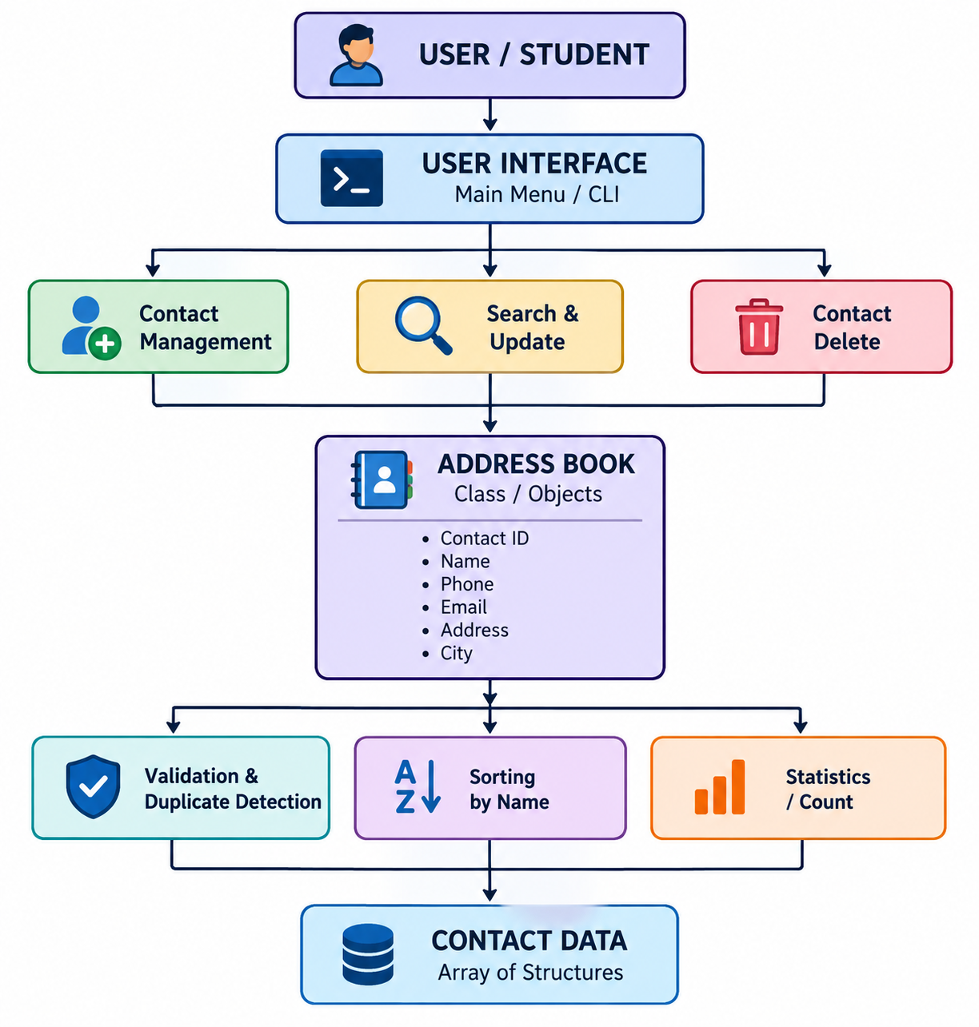
Fig. 1.1 System architecture of the Address Book System.

Algorithm

Algorithm: Address Book System
Step 1: Start the application.
Step 2: Display the welcome screen.
Step 3: Display the main menu.
Step 4: Accept the user's choice.
Step 5: Execute the selected operation:
- Add Contact
- Display Contacts
- Search Contact
- Update Contact
- Delete Contact
- Sort Contacts
- Display Statistics
- Exit
Step 6: Validate input wherever required.
Step 7: Process the requested operation.
Step 8: Display the result.
Step 9: Return to the main menu.
Step 10: If the user selects Exit, terminate the application.
Step 11: Stop.

Flowchart:
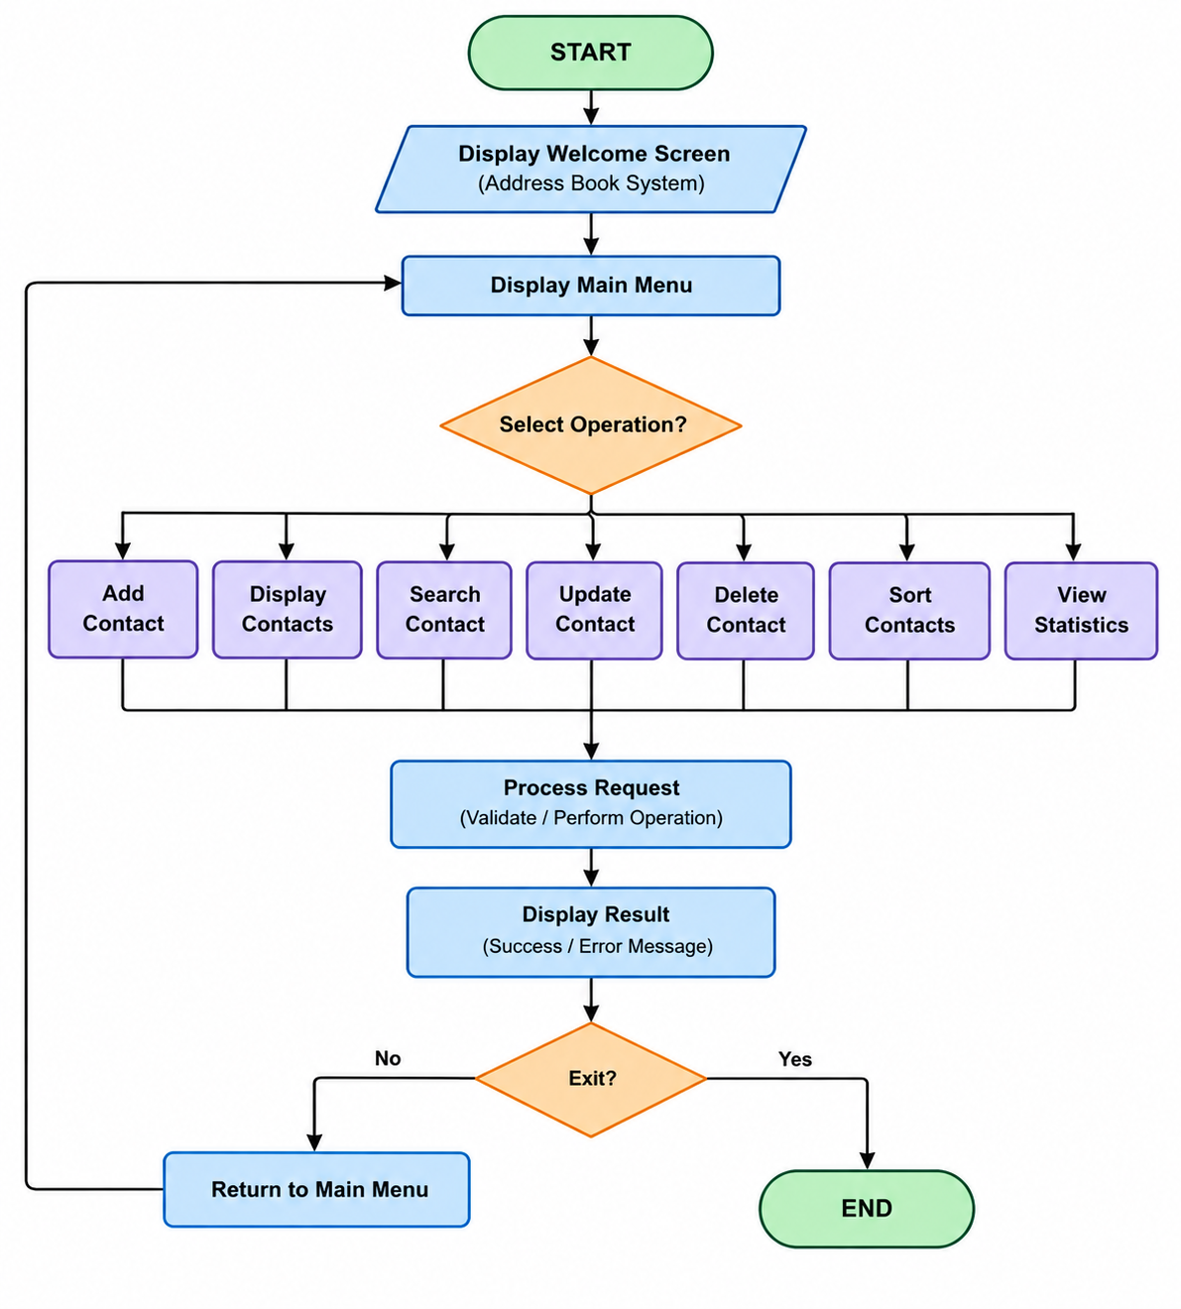
Fig. 2. Overall flowchart of the Address Book System

CHAPTER–2

PROJECT IMPLEMENTATION

OOP Concepts Used for Implementation
The system uses fundamental Object-Oriented Programming concepts to provide modular and organized implementation.

Class
A class named AddressBook is used to group contact-management data and functions.

Object
Objects of the AddressBook class are used to access the operations defined by the class.

Encapsulation
Contact-management data and related operations are organized within the class. Private data members can be accessed through public member functions.

Abstraction
The internal implementation of operations such as searching and deleting is hidden from the user. The user interacts only through menu options.

Constructor
A constructor can be used to initialize the Address Book object and set initial values such as the contact count.

Structures
A Contact structure is used to group related contact attributes.

Arrays
An array of Contact structures can be used to store multiple contact records.

String Handling
C++ strings are used to store names, phone numbers, email addresses, cities, and residential addresses.

Code:
Contact Structure :
struct Contact
{
int contactID;
string name;
string phone;
string email;
string address;
string city;
};
The structure represents an individual contact record.
AddressBook Class :
class AddressBook{
private:
Contact contacts[100];
int count;
public:
AddressBook();
void addContact();
void displayContacts();
void searchContact();
void updateContact();
void deleteContact();
void sortContacts();
void showStatistics();
};
The AddressBook class manages the contact records and provides member functions for performing different operations.

Add Contact:
The Add Contact operation accepts the contact details from the user, validates the required information, generates a Contact ID, and stores the record.
Processing sequence:
Input Contact Details
↓
Validate Information
↓
Check Duplicate Phone
↓
Generate Contact ID
↓
Store Contact
↓
Display Success Message

Display Contacts:
The Display operation reads all available records and presents them in a structured table.
Typical information displayed includes:
- Contact ID
- Name
- Mobile Number
- Email
- Address
- City

Search Contact:
The system supports searching using selected contact information.
Search options include:
- Contact ID
- Name
- Mobile Number
The system compares the entered search value with the stored records and displays matching information.

Update Contact:
The Update operation identifies a contact using its Contact ID and allows the user to modify the stored information.
The updated fields may include:
- Name
- Mobile Number
- Email
- Address
- City
After validation, the modified information replaces the previous values.

Delete Contact:
The Delete operation removes a selected contact using its Contact ID.
If the contact is found, the user is asked to confirm the deletion. After confirmation, the remaining records are shifted appropriately to maintain the array structure.

Sort Contacts:
The sorting operation arranges contact records alphabetically based on the contact name.
For an array-based implementation, a simple comparison-based sorting technique can be used.

Validation and Duplicate Detection:
The system performs basic validation before storing contact information.
Examples include:
- Checking mobile-number length.
- Checking whether required fields are empty.
- Checking whether a phone number already exists.
This reduces duplicate and invalid contact records.

Main Menu:
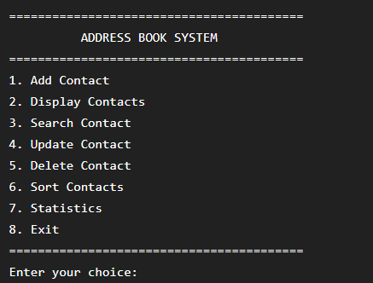
Fig. 3. Main menu interface of the Address Book System.

OUTPUT SCREENS
The following output screens demonstrate the major functionalities implemented in the Address Book System.

Welcome Screen
The welcome screen introduces the application and provides a clear entry point for the user.
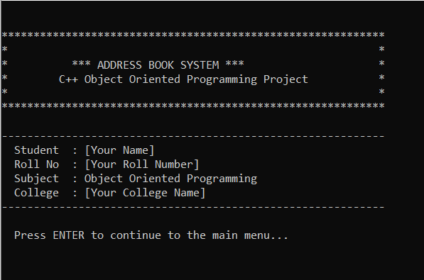
Fig. 4. Welcome screen of the Address Book System.

Main Menu
The main menu provides access to the available contact-management operations.
Fig. 5. Main menu of the Address Book System.

Add Contact
The Add Contact screen accepts the details required to create a new contact.
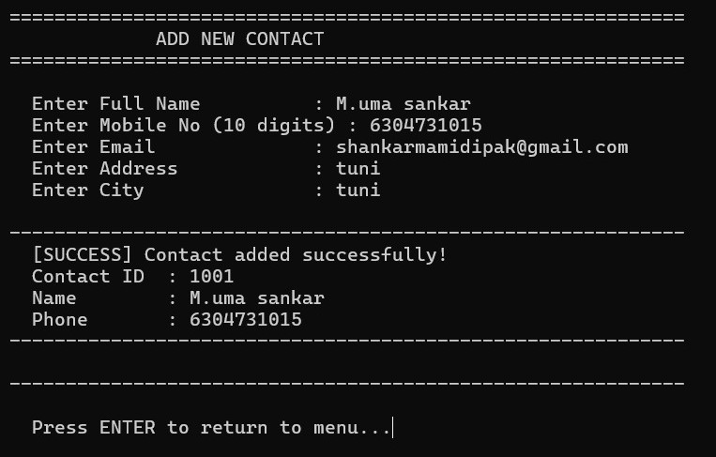
Fig. 6. Add contact operation.

Display Contacts
The Display Contact screen presents all stored records in a tabular format.
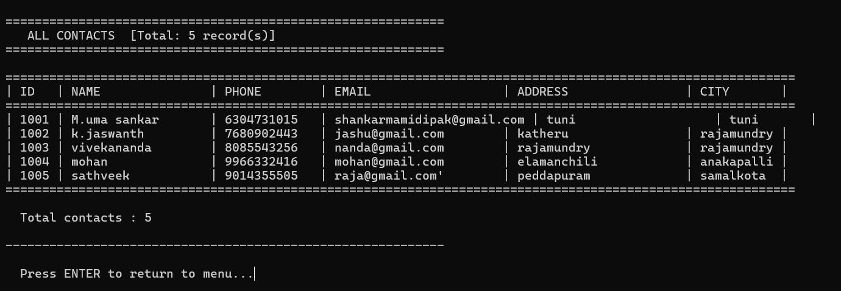
Fig. 7. Display contacts operation.

Search Contact
The Search Contact screen allows the user to enter a search criterion and retrieve the corresponding record.
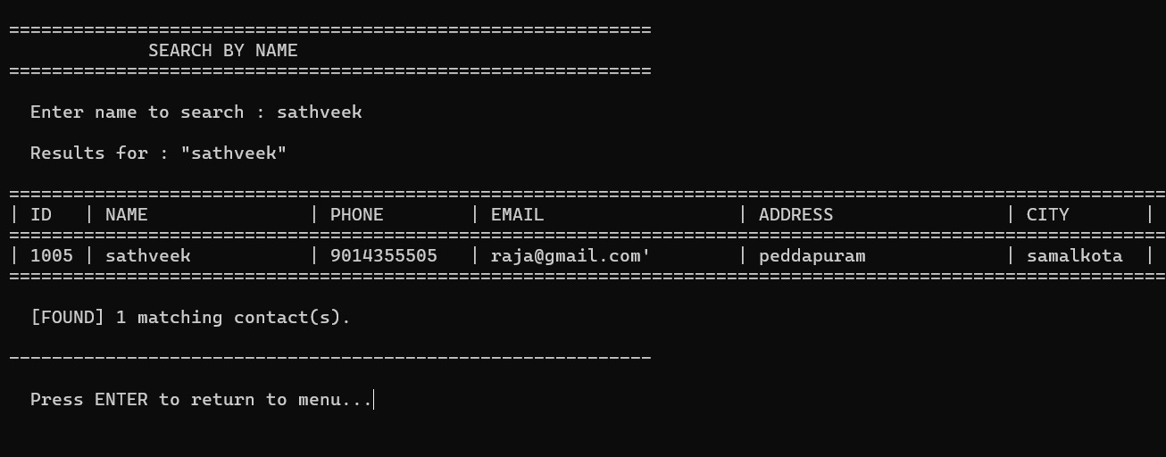
Fig. 8. Search contact operation.

Update Contact
The Update screen allows modification of existing contact information.
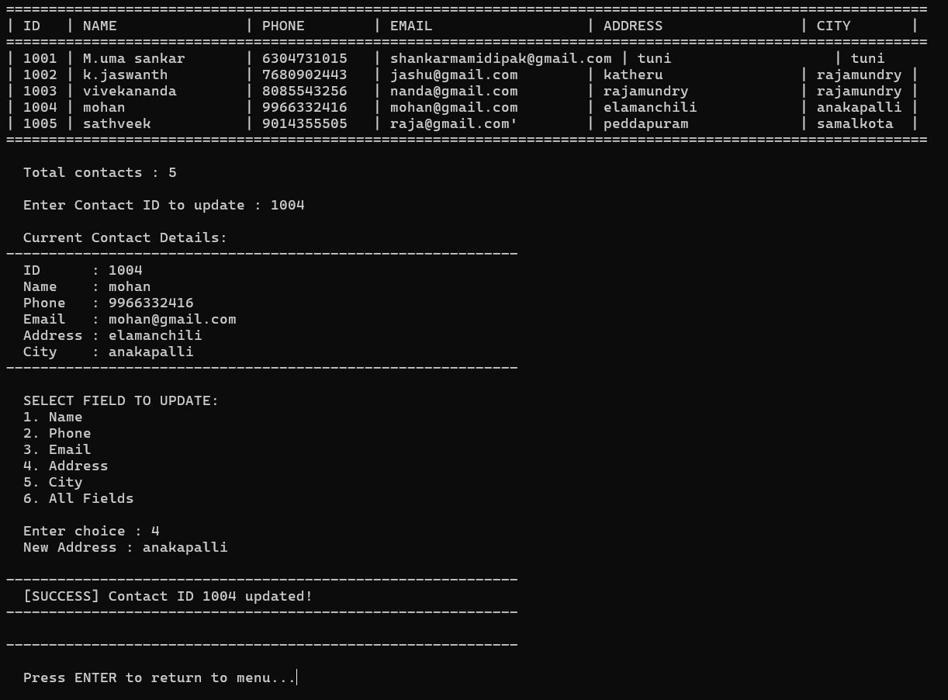
Fig. 9. Update contact operation.

Delete Contact
The Delete operation removes a selected contact after confirmation.
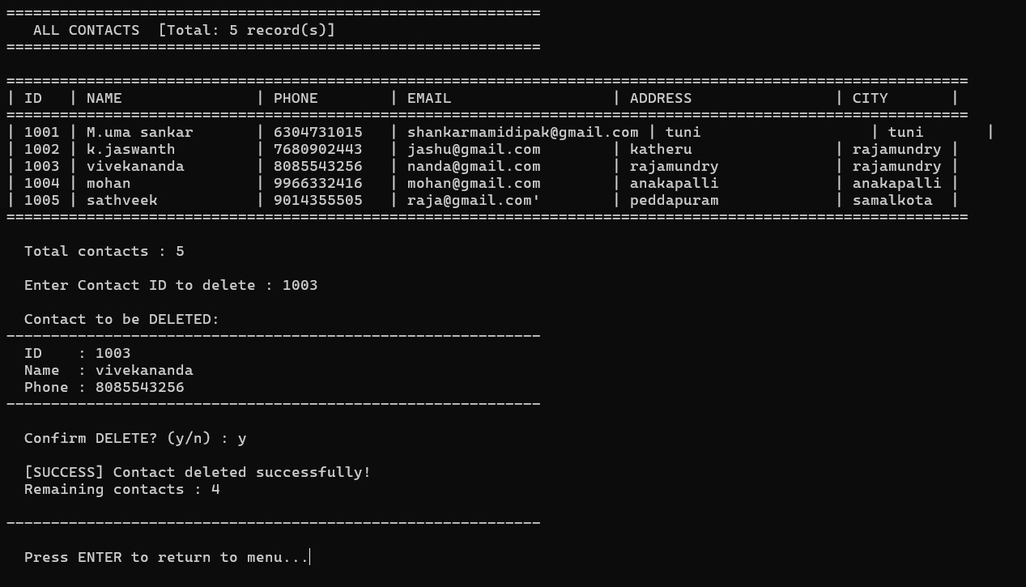
Fig. 10. Delete contact operation.

Sorting and Validation
The sorting functionality organizes contacts alphabetically, while validation prevents incorrect or duplicate entries.
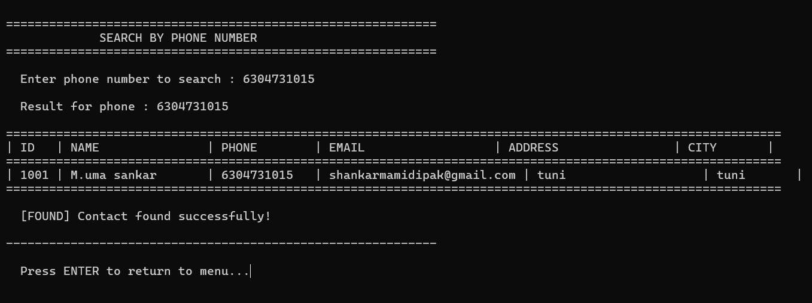
Fig. 11. Sorting and validation operations.

CHAPTER–3

CONCLUSION AND FUTURE SCOPE

Conclusion
The Address Book System using C++ and Object-Oriented Programming successfully provides a structured solution for managing contact information. The system supports essential operations including contact creation, display, searching, updating, deletion, sorting, validation, and basic statistics.
The project demonstrates the practical implementation of fundamental OOP concepts such as classes, objects, encapsulation, abstraction, constructors, structures, arrays, and member functions. The menu-driven interface provides a simple method for interacting with the application.
Compared with traditional manual address books, the proposed system provides a more systematic approach to organizing and retrieving contact information. Features such as automatic Contact ID generation, duplicate detection, and input validation further improve the reliability of the application.
Overall, the project demonstrates how fundamental C++ programming and OOP concepts can be applied to develop a practical contact-management application.

Future Scope
The current system is designed as a basic C++ application and can be extended with additional functionality.
Possible future enhancements include:
- File Handling – Store contacts permanently in files so that records remain available after program termination.
- Database Integration – Connect the application to a database for managing a larger number of contacts.
- Graphical User Interface – Replace the console-based interface with a graphical interface.
- Advanced Search – Provide filtering by city, email, name, or multiple fields simultaneously.
- Contact Groups – Allow contacts to be categorized into groups such as Family, Friends, College, and Work.
- Import and Export – Support importing and exporting contact records in standard formats such as CSV.
- Enhanced Validation – Provide more comprehensive validation for email addresses and other contact fields.
- Authentication – Introduce user authentication to restrict unauthorized access to contact information.
- Backup and Recovery – Provide facilities for backing up and restoring contact records.
- Cross-Platform Interface – Extend the application for use across different operating systems.

REFERENCES
You can use a short reference section such as:
[1] B. Stroustrup, The C++ Programming Language, 4th ed. Addison-Wesley, 2013.
[2] S. B. Lippman, J. Lajoie, and B. E. Moo, C++ Primer, 5th ed. Addison-Wesley, 2012.
[3] ISO/IEC, ISO/IEC 14882:2020 — Programming Languages — C++, International Organization for Standardization, 2020.

